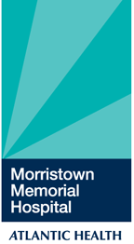
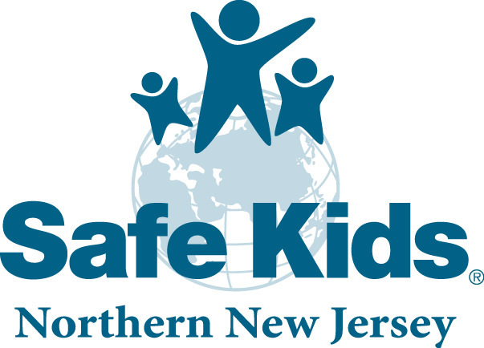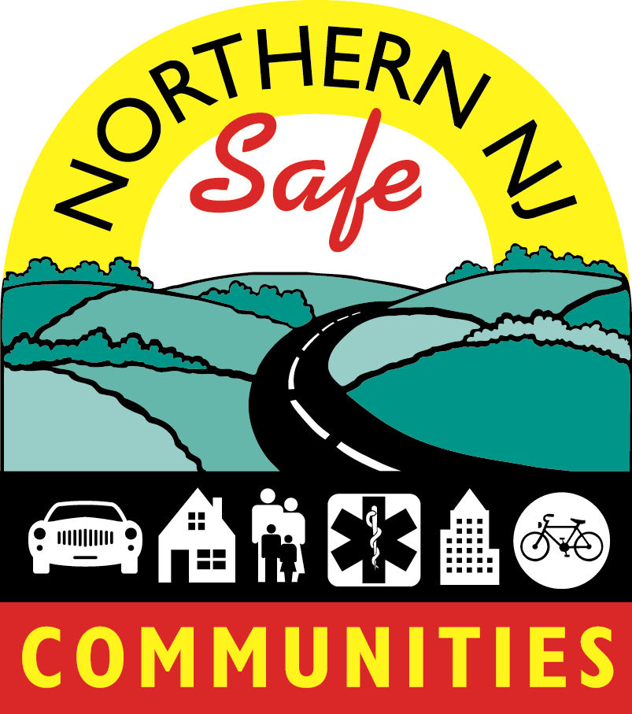

Traffic Safety Mini Grant Proposal
Grant Year Oct. 1, 2009- Sept. 30, 2010

Complete the form below to submit a Community Traffic Safety Grant Proposal. Return the form to KJ Feury at karenjean.feury@atlantichealth.org , fax 973-290-7350 or mail to Morristown Memorial Hospital 100 Madison Ave. Morristown NJ 07960 attention KJ Feury .

Proposals will be accepted and reviewed on a first come first serve basis till the funding is all awarded. Projects must include a local community group. Maximum funding is $500.00.

All projects must be completed by September 1, 2010. Please submit a project summary upon completion.

Organization
Address
Phone
Fax
Project Coordinator
Local Community Group
Title of Project
Purpose of Project
Project Evaluation Method

